Multiple-choice section

|  |  |  |  |  |  |  |  |  |
| --- | --- | --- | --- | --- | --- | --- | --- | --- |
| Question | 1 | 2 | 3 | 4 | 5 | 6 | 7 | 8 |
| Answer | D | D | A | B | C | B | A | D |

Question 1 [6.1]

**D**

20°, 13°

Corresponding angles means that they are equal.

*a* + 35 = 55

*a* = 55 – 35

*a* = 20°

Alternate angle to 55°

5*b* – 10 = 55

*5b =* 55 + 10

5*b* = 65



Question 2 [6.1]

**D**

Interior angle = 180 – 72 – 56 = 52°

*a* = 180 – 52 = 128° (straight angle)

*b* = 180 – 72 = 108° (straight angle)

*c* = 180 – 56 = 124°

Question 3 [6.2]

**A**

Triangles *A* and *B* are congruent by ASA.

Question 4 [6.4]

**B**



Question 5 [6.3]

**C**

The co-interior angles within a parallelogram add to 180°.

Question 6 [6.7]

**B**

A pentagonal prism contains 10 vertices, 7 faces and 15 edges.

Question 7 [6.7]

**A**

A *prism* is a solid with two identical polygon ends and a uniform cross-section.

Question 8 [6.4]

**D**

*A*′*B*′ = 0.5 × 1.6 = 0.8 cm

Multiple-choice total marks: 8

Short answer section

Question 9 3 marks [6.3]

**(a)** Quadrilateral

(4*x* – 18) + 6*x* + 2*x* + 90 = 360°

12*x* + 72 = 360

12*x* = 288

*x* = 24°

**(b)** Parallelogram

2*a –* 20+ 3*a* = 180° (co-interior angles in parallel lines)

5*a* – 20 = 180

5*a =* 180 – 20

5*a* = 160



*a* = 32°

*b* = *2a – 20*  (opposite angles of a parallelogram)

= 2 × 32 – 20

= 44°

**(c)** Pentagon

3*x* – 12 = 72° (exterior angle of a regular pentagon)

3*x* = 72 – 12

3*x* = 60

*x =* 20°

Question 10 6 marks [6.1]

**(a)** 4*e* + *e* + 65° = 180° (angle sum of triangle)

5*e* = 115°



*e* = 23°

*a* = 4*e* (alternate angles in parallel lines)

= 4 × 23°

= 92°

*c* + 65° = 180° (corresponding angles on parallel lines, straight angle equals 180°)

*c* = 115°

**(b)**

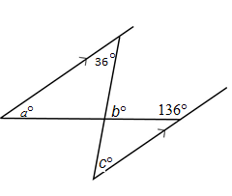

*a* + 136° = 180° (co-interior angles in parallel lines)

*a* = 44°

*c* = 36° (alternate angles on parallel lines)

*b* = 44° + 36° (exterior angle of a triangle)

*b* = 80°

**(c)**

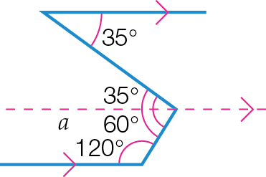

By creating an alternate angle:

alternate angle = 35°

co-interior angle = 60°

*a* = 35 +60 = 95°

Question 11 3 marks [6.1]

|  |  |
| --- | --- |
| **(a)** | *x* + 42 + (3*x* + 38) = 180° (straight angle)  4*x* + 80 = 180  4*x* = 100    *x* = 25° |

**(b)** (2*y* – 12) + 42 = 180° (co-interior angles in parallel lines)

2*y* + 30 = 180

2*y* = 150

*y* = 75°

**(c)** *x* – *y* + *z* = 42 + *x* (corresponding angles on parallel lines)

25 – 75 + *z* = 42 + 25

*z* – 75 = 42

*z* = 117°

Question 12 5 marks [6.2]

Proof:

In ∆*ABC* and ∆*EDC*,

∠ *BAC* = ∠ *CED* (alternate angles, *AB* || *DE*)

∠ *ACB* = ∠ *ECD* (vertically opposite angles)

*AB* = *DE* (given)

∴ ∆ *ABC* ≡ ∆ *EDC* (AAS)

∴ *AC* = *CE* (matching sides of congruent triangles)

Question 13 2 marks [6.6]

|  |  |
| --- | --- |
|  | The triangles are similar as the vertically opposite angles are equal, the pairs of alternate angles are equal.  Hence the pairs of matching sides are proportional. |

Question 14 8 marks [6.1,6.5,6.6]

|  |  |  |
| --- | --- | --- |
| **(a)** | ∠*A* is common.  ∠*ADE* = ∠*ABC*  Therefore ∆*ABC* ~ ∆*ADE* by AAA.    *x*(*x* + 5) = 10 × 5  *x*2 + 5*x* = 50    Therefore *x* = 5 (*x* = -10 can be ignored as *x* represents a length) | |
| **(b)** | *A* is common.  *ADE* = *ABC* = 90°  Therefore ∆*ABC* ~ ∆*ADE* by AAA. | |
| **(c)** | *c* = 120° (corresponding angles on parallel lines)  *b* = 60° (supplementary adjacent angles)  *a* + 60° + 60° = 180° (angle sum of isosceles triangle)  *a* = 60° | |
| **(d)** | |  |

Question 15 3 marks [6.7]

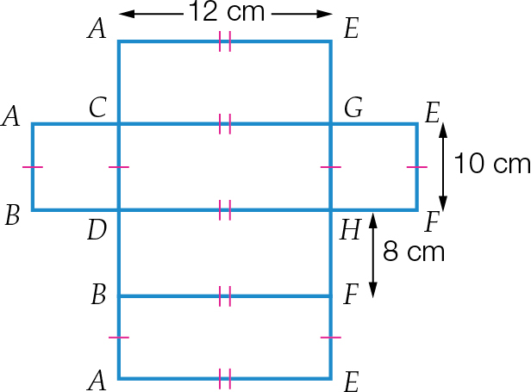

Question 16 2 marks [6.6]

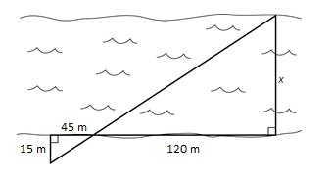

The vertically opposite angles and pair of right angles shows that that two triangles are similar by AAA.



The river is 40 m wide.

Question 17 5 marks [6.5]

|  |  |
| --- | --- |
| **C:\Users\Maja\AppData\Local\Microsoft\Windows\INetCache\Content.Word\PM2e_09_EB_06_SBT_14.jpg** | ∠*A* = 180 – 65 – 45 = 70°  ∠*D* = 180 – 70 – 65 = 45°  In ∆*ABC* and ∆*DEF*  ∠*BAC* = ∠*DEF* = 70°  ∠*ABC* = ∠*DFE* = 65° (given)  ∠*ACB* = ∠*EDF* = 45°  ∴ ∆*ABC* ~ ∆*EFD* (AAA)  Matching sides of similar triangles are proportional:        *a* = 3 cm |

Question 18 2 marks [6.4]

**(a)** side of small pentagon = 2 cm   
side of large pentagon = 3 cm

scale factor = 3 ÷ 2 = 1.5

**(b)** scale factor = 2 ÷ 3 = 

Question 19 4 marks [6.6]

|  |  |
| --- | --- |
| C:\Users\Maja\AppData\Local\Microsoft\Windows\INetCache\Content.Word\PM2e_09_EB_06_SBT_15.jpg | In ∆*PQR* and ∆*STR*,  ∠*PRQ* = ∠*SRT* (common angle)  ∠*PQR* = ∠*STR* = 90° (given)  ∠*RST* = ∠*RPQ* (angle sum of triangle)  ∴ ∆*PQR* ||| ∆*STR* (AAA)  Matching sides of similar triangles are proportional: |

Question 20 3 marks [6.2]

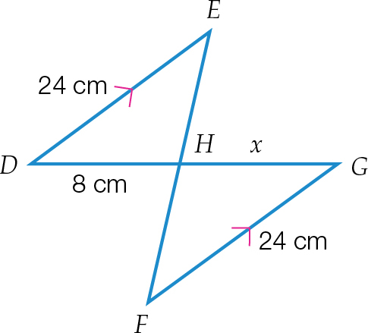

In ∆*DEH* and ∆*GFH*,

∠*DEH* = ∠*GFH* (alternate angles, *DE* || *FG*)

∠*EHD* = ∠*FHG* (vertically opposite angles)

*DE* = *FG* (both 24 cm, given)

∴ ∆*DEH* ≡ ∆*GFH* (AAS)

∴ *x* = 8 cm (matching sides of congruent triangles)

Question 21 3 marks [6.5]

**(a)** scale factor = 2 ÷ 8 = 

**(b)**

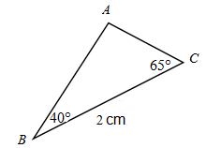

Question 22 1 mark [6.4]

Original area:



Scale factor = 

New area:



Short answer total marks: 50

Extended answer section

Question 23 9 marks [6.5]

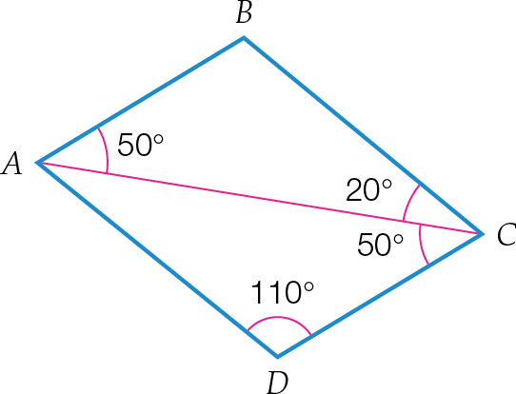

**(a)** *ABC* = 120° (angle sum of triangle)

∠*CAD =* 20° (angle sum of triangle)

In ∆*ABC* and ∆*CDA*

∠*BAC* = ∠*ACD* = 50° (given)

∠*ABC* = ∠*CDA* = 110°

∠*CAD* = ∠*ACB* = 20°

∴ ∆*ABC* ~ ∆*CDA* (AAA)

**(b)** *AC* is a common side, so:

In ∆*ABC* and ∆*CDA*

∠*BAC* = ∠*ACD* = 50° (given)

∠*ABC* = ∠*CDA* = 120°

*AC* is a common side

∴ ∆*ABC* ≡ ∆*CDA* (AAS)

**(c)** ∠*BAC* = ∠*DCA* = 50°

These are a pair of alternate angles contained between *AB* and *DC*, hence *AB* || *DC*.

∠*DAC* = ∠*BCA* = 20°

These are a pair of alternate angles contained between *AD* and *BC*, hence *AD* || *BC*.

**(d)** *ABCD* is a parallelogram as it has both pairs of opposite sides parallel (also equal from congruent triangles).

Question 24 2 marks [6.6]

To find the length of the brace *HI*. Draw the triangles involved.

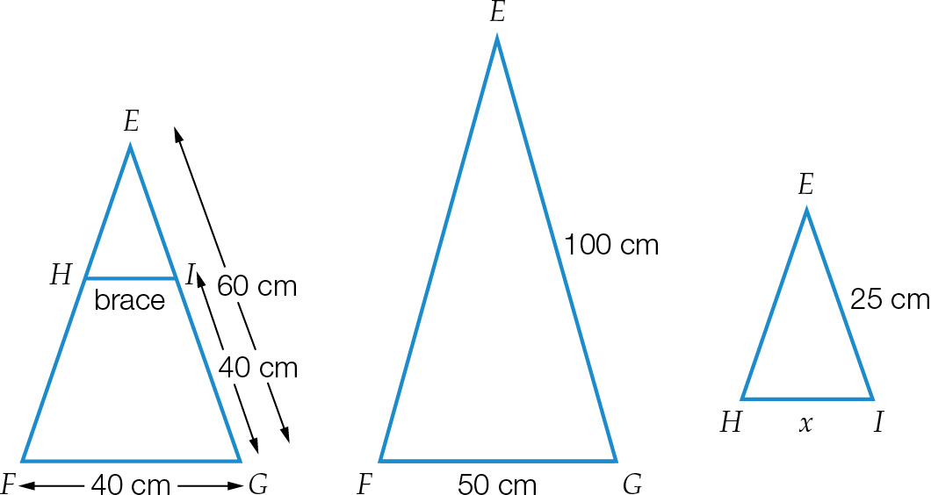

∠*E* is common to both.

∠*EHI =* ∠*EFG* (corresponding angles on parallel lines)

∠*EIH =* ∠*EGF* (corresponding angles on parallel lines)

Therefore ∆*EFG* ~ ∆*EHI* because AAA.





*x =* 12.5 cm

Extended answer total marks: 11

TOTAL test marks: 69